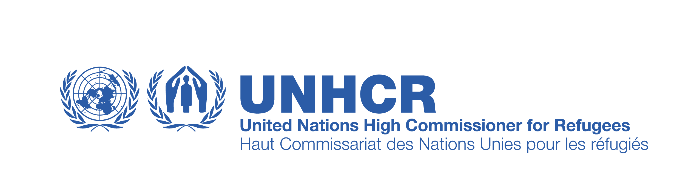

UNITED NATIONS HIGH COMMISSIONER FOR REFUGEES (UNHCR)
INTERNAL/ EXTERNAL VACANCY ANNOUNCEMENT
Vacancy Notice No. TUNZA/012/2022

Title of Post | Programme Associate | Category/grade | TA
Location | Zarzis, Tunisia | Type of contract | UNHCR
Date of Issue | 04 June 2022 | Closing Date | 19 June 2022
The effective date of assignment | Immediately | Duration of contract | 6 months with the possibility of extension

Operational Context:

The Programme Associate will be based in the Field Office Zarzis (Tunisia) she/he will be supervised and the Head of Field Office. S/he is expected to stay abreast of the challenges posed by the operational context, the UN, and humanitarian reform and institutional developments.

The Programme Associate is expected to have contacts within the organization and outside the duty station, as well as with partners and other stakeholders to collect information, monitor programme activities, and implement administrative requirements. The incumbent will have to establish good working relationships with their peers at the country level to facilitate the collection of information and other programme management-related activities.

For the South, all activities are to be coordinated with the Head of Field Office as direct supervisor and technically with the Associate Program Officer as technical supervisor (Zarzis/Tunis).

Functional Statement:

The Programme Associate is a member of the Program Unit and the Refugee Status Determination (RSD) team. Under the direct supervision of the Head of Field Office, she/he will undertake the following duties and responsibilities:

- Support the assessment and analysis of the needs of persons of concern in the country/region in a participatory manner and using an Age, Gender and Diversity (AGD) perspective as basis for planning.
- Assist in managing the development of a broad network of partners, good coordination practices and the development of partner capacities related to programme management if applicable.
- Assist in organizing and documenting the selection of partners in accordance with the policy on selection and retention of partners, ensuring due diligence to meet the requirements of projects.
- Provide support to the field with technical advice to ensure partnership agreements are established in a timely manner, regularly monitored and reported on in compliance with established guidelines and procedures included in the framework for implementing with partners.
- Support the implementation and performance of partnership agreements through field visits and appropriate physical monitoring if applicable, reviewing performance and financial reports.
- Support the development and implementation of MFT monitoring plans for activities implemented through partnerships and those under direct implementation in line with Programme Manual and programming instructions.
- Contribute to the review and analysis of operations plans, mid-year and year-end reports of the different UNHCR offices, ensuring quality assurance and compliance with established policies, guidelines, procedures and standards. Generate and maintain records of implementation rate (performance progress and expenditures) on a regular basis.
- Follow up on any change in regards to alignment of results chain, verifying indicators, budget, prioritization, apportioning needed to measure programme performance, trends and target interventions, contributing to soundness of Operations Plan and enhancement of data quality.
- Follow up with UNHCR offices the compliance with issuance of audit certificates for partners in line with the Policy on Risk-Based Project Audits.
- Provide support to the field through technical advice and training on resource allocation processes and other programmatic issues.
- Use UNHCR’s corporate tools (e.g. Focus Client, Global Focus Insight and FOCUS Reader, MSRP) for core activities related to planning, budgeting, implementation and reporting, generating data for evidence-based programmatic decisions and analysis.
- Support UNHCRs programming of community of practice and continuously contributing to improvements of programming tools and processes.
- Monitor the warehouses management aspects of UNHCR warehouses that manage by partner in the south.
- Perform other duties as required

Minimum Qualifications

Education & Professional Work Experience

Years of Experience / Degree Level

3 years relevant experience with High School Diploma; or 2-year relevant work experience with Bachelor or equivalent or higher

Certificates and/or Licenses

Business Administration, Finance, Office Management, Economics, or another related field.;

Language Requirements

.
Excellent knowledge of English, French and Arabic

Vaccination COVID-19

The applicant must prove vaccination

How to apply – make it personal!
- We want to know how you stand out from the crowd – what motivates you to join our team, what skills and energy would you bring, why is UNHCR and Tunisia important?
- Please send a Personal History Form (PHF) and its supplementary pages (if applicable), motivation letter (1 page max.) by e-mail to tuntu@unhcr.org indicating “Data Management Associate” in the subject of the email.
Applications must be submitted to the following email address:

tuntu@unhcr.org

No late applications will be accepted. Only shortlisted candidates will be contacted. Shortlisted candidates may be required to sit for an oral interview. UNHCR does not charge a fee at any stage of the recruitment process (application, interview, processing or any other fees).

UNHCR strongly encourages qualified female applicants for this position. UNHCR seeks to ensure that male and female employees are given equal career opportunities. UNHCR is committed to achieving workforce diversity in terms of gender, nationality and culture. All applications will be treated with the strictest confidentiality.

Refugees – who cares? We Do

