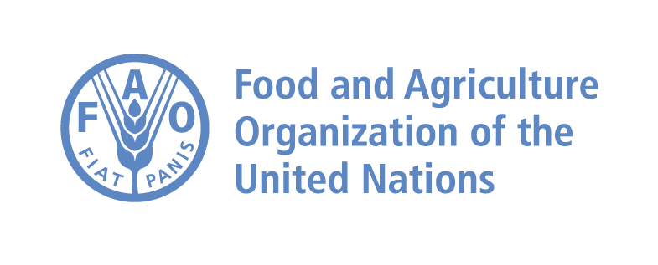
FAO holds a training for Farmer Field Schools facilitators on managing date palm pests in Tunisia.
$280 million worth of dates is Tunisia’s share in global trade in 2021, the Maghreb produces 15% of the global production of dates.

18 – 22 September 2023, Tunis - Within the framework of the regional programme for Red Palm Weevil (RPW) management in the Near East and North Africa region, the Food and Agriculture Organization of the United Nations (FAO) is holding a training programme for Farmer Field Schools (FFS) facilitators on managing the Red Palm Weevil (RPW) and other date palm pests in Tunis from 18 to 22 September 2023. The training is attended by FAO regional experts and trainers and more than 20 trainees from Tunisia and Libya.
The program aims to enhance the capacities of agricultural specialists to establish, implement, and manage FFSs; enhance the skills and capacities of farmers to manage the RPW and other date palm pests; and adopt good agricultural practices.
"Tunisia and Libya play a vital role in the date sector, as Tunisia is ranked at the top of the list of date exporting countries in the world, accounting for a large share of the global trade volume of dates, with USD 280 million worth of dates exported in 2021," said Thaer Yaseen, Regional Plant Protection Officer at the FAO Regional Office for NENA.
"Recent studies evaluating RPW social and economic impact in NENA showed that the annual cost of RPW management programmes amounted to approximately 5.7 million USD in Egypt and about 34.4 million USD in Saudi Arabia. This called for training programmes to control the RPW in the region through scientific research, capacities building of farmers and workers in the date palm sector and exchanging technology and information between countries in the region,” explained Yaseen.
"The Maghreb region, which includes Morocco, Algeria, Tunisia, Mauritania, and Libya, produces about 15 percent of the global production of dates, "said Dr. Mohamed Rabeh Al-Hajlawi, Director General of Plant Health and Control of Agricultural Inputs at the Tunisian Ministry of Agriculture, Water Resources and Fisheries.
"Date production in Tunisia is witnessing increasing interest, making the date sector one of the most important pillars of the economy. The planted area with date palms has increased over the past 20 years to 40 thousand hectares, approximately 5.4 million palm trees. Its production rate reached 195 thousand tons, including 135 thousand tons of the Deglet Nour variety, significantly impacting the national economy,” added Al-Hajlawi.
"Although date palm farmers are considered the main link in all control programs, their participation in most countries in the region remains limited,” stated MohamedelHady Sidatt, Plant Protection Officer at the FAO Sub-Regional Office for North Africa. He pointed out that this workshop contributes to strengthening this participation, the intervention of farmers to support state efforts, in addition to building the capacities of national officials and enhancing the coordination between the state and the farmers’ sector.
"The workshop aims to prepare human capacities to supervise FFSs in both Tunisia and Libya for the Integrated Pests Management of date palm pests as well as RPW," added Sidatt.
RPW is a serious pest that attacks around 40 species of palms in more than 50 countries, causing widespread damage to palm trees and other crops and affecting production, farmers' livelihoods, and the environment. The Regional programme for the RPW management in NENA has developed five working groups in the areas of RPW monitoring and early detection, activating the participation of farmers, developing RPW control protocols and techniques, studying RPW social and economic impacts, and developing phytosanitary systems and border protocols, as well as producing certified palm propagation materials for sustainable RPW management.

