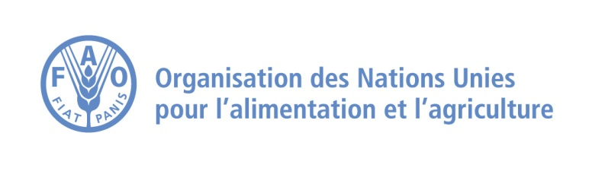

**Closure of the regional capacity-building workshop and conference on financing the transformation of agri-food systems**

***Establishment of a technical assistance platform for Member States to deploy financing mechanisms and strategic investments for the transformation of agri-food systems***

**Tunis, 20-23 January 2025:** The FAO Regional Office for the NENA region and North Africa organized a workshop to address the challenges of financing the transformation of agrifood systems in the countries of the NENA region. The event focused on bridging the financing gap to promote sustainable agriculture and greater resilience to climate change.

Despite its essential role in combating food insecurity, agriculture remains largely underfunded. Existing public investments are often not aligned with the objectives of healthy eating and sustainable practices. To bridge this gap, it is essential to attract inclusive and effective investment from both the public and private sectors. Sustainable finance can have a transformative impact, tackling climate change, biodiversity loss and equitable access to healthy food, while promoting green jobs, particularly for women and young people.

Conducted with the aim of building the capacity of expert delegations representing countries in the region, the event included interactive workshops that explored the challenges of financing by focusing on reallocating existing public support to agri-food systems and how to make regulatory systems more conducive to innovative financing mechanisms and strengthen public-private partnerships.

Participants learnt how to develop sustainable, investable projects, using innovative software and tools such as Rural Invest, ExACT and GLEAM.

At the end of the workshop, a ‘TIP’ platform was launched. This will provide funding mechanisms to facilitate strategic investments, grants and blended funding instruments for the transformation of regional agrifood systems. This platform stems from the Cairo Declaration of 2024, which proposes to launch a collaborative financing mechanism with the ownership of beneficiary governments, and in collaboration with development and financing partners.

The TIP platform will provide a consortium of technical assistance to help Member States structure and deploy financing instruments. This will provide grants and investment capital to support the deployment of innovative financing instruments to improve food security and nutrition, protect or improve rural livelihoods and promote the initiative's commitment to gender equity, inclusion and environmental sustainability.